PRESS RELEASE Contact: Penny Patterson
Sr. Director, Communications
Promega Corporation
Phone: (608) 274-4330
E-mail: penny.patterson@promega.com

Promega Spring Art Showcase Presents An International
Celebration of Women Through Art

Madison, WI USA. (February 13, 2013) The Promega Spring Art Showcase presents An International Celebration of Women Through Art. Inspired by International Women’s Day, the showcase features the struggles and empowerment of women. The exhibit will feature artists Dr. Lilian Nabulime (Uganda), Michael Kienitz (Latin America) and Jane Madrigal (US/Latina).
- Dr. Lilian Nabulime – An artist, senior lecturer, and former Head of the Sculpture Department at Makerere University in Uganda. Nabulime’s work uses everyday objects from Ugandan women’s lives (i.e. soap, sieves, cloth, mirror) to embody a specific social agenda to raise awareness and promote discussion about sexual practice and HIV/AIDS. Her work attempts to move the meaning of art beyond the visual and into the social. Nabulime resides in Kampala, Uganda.
- Michael Kienitz – A photographer for over 40 years, his work has appeared in Life, Time, Newsweek and other publications worldwide. In this exhibit Kienitz’s photography documents inspiring microfinance borrowers and coffee farmers in Latin America. Kienitz collaborated with Working Capital for Community Needs (WCCN), a nonprofit organization that empowers low-income Latin American entrepreneurs and small-scale farmers through microcredit, fair trade, housing projects and women’s empowerment initiatives. Kienitz is a photojournalist instructor at the University of Wisconsin in Madison, Wisconsin.
- Jane Madrigal – A Chicana artist and muralist, her work reflects her indigenous culture, the power of women, and a vision of a better future for the next generation. Madrigal will exhibit Revolutionary Women woodcut prints focusing on the women who have struggled, survived and shown solidarity and organized transformative social change. Madrigal is a cultural arts educator in San Antonio, Texas.

--MORE--
2-2-2-2 Promega Spring Art Showcase

The showcase opens Tuesday, March 12, 2013 and continues through June 7, 2013 at the Promega BioPharmaceutical Technology Center in Madison. The exhibit is open Monday through Friday 8:00am to 4:00pm. A public art opening reception will be held on Tuesday, March 12th from 4:30pm – 6:30pm.

Daniel Swadener, in conjunction with Promega, is the producer of the art exhibit. For more information Daniel can be contacted through e-mail at swadener@gmail.com or visit his web site at: danielswadener.com.

Promega Corporation has sponsored the artist's showcase since 1996 as part of the company's commitment to creativity and innovation in the arts, cultures and sciences. The Biopharmaceutical Technology Center, located on 5445 East Cheryl Parkway two miles south of Highway 12/18 (Beltline) off Fish Hatchery Road, was developed, in part, to provide Promega employees and community members a place to pursue these goals.

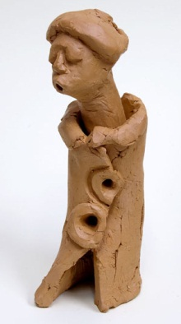 | Sculpture by Dr. Lilian Nabulime |  | Photo by Michael Kienitz
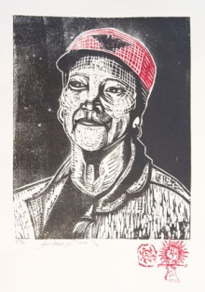 | Woodcut print by Jane Madrigal

High resolution images available upon request.

# # # #

